3R Company Website

I used HTML, CSS, and JavaScript to finish all the Front-End Parts and User features.

There is including 6 parts:

1. Home page, 2. About page, 3. Service page, 4. Doctor page and

5. Book appointment page 6. Contact part

You can use Visual Studio Code to open the folder and run the website.

1. Home Page

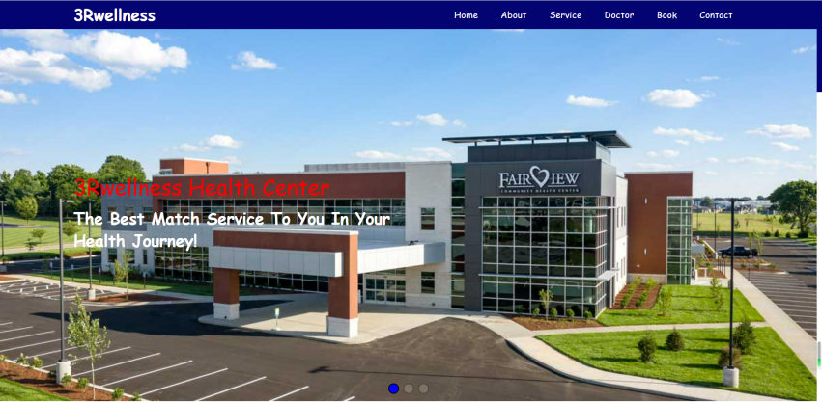

1. 公司介绍页面 - About Page

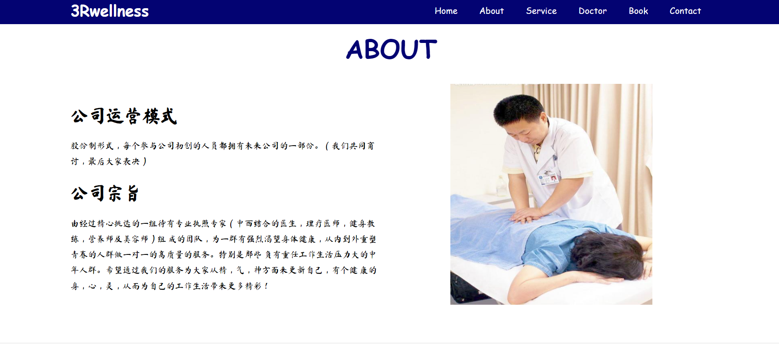

1. 服务页面 - Service Page

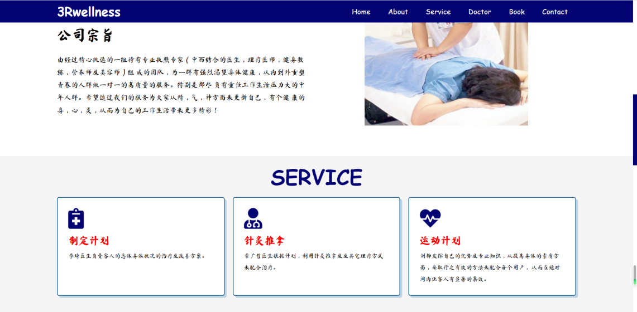

1. 专家团队介绍页面 - Doctor Page



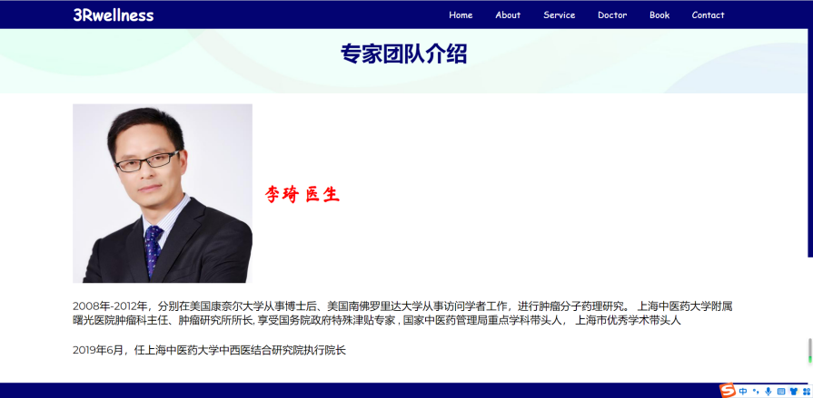

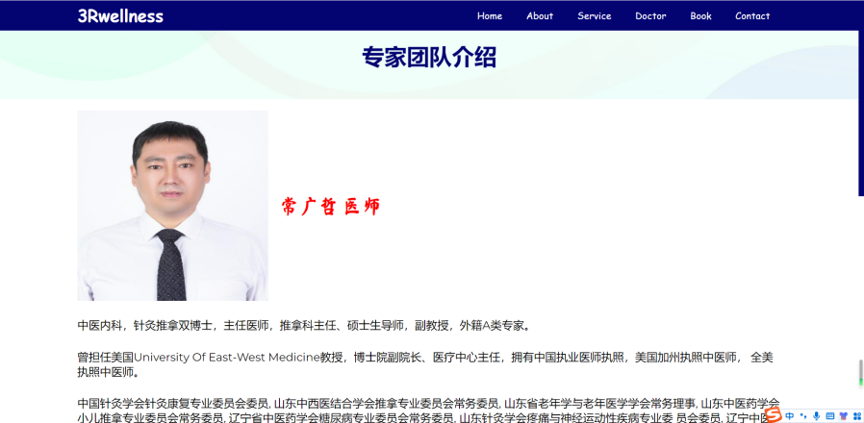

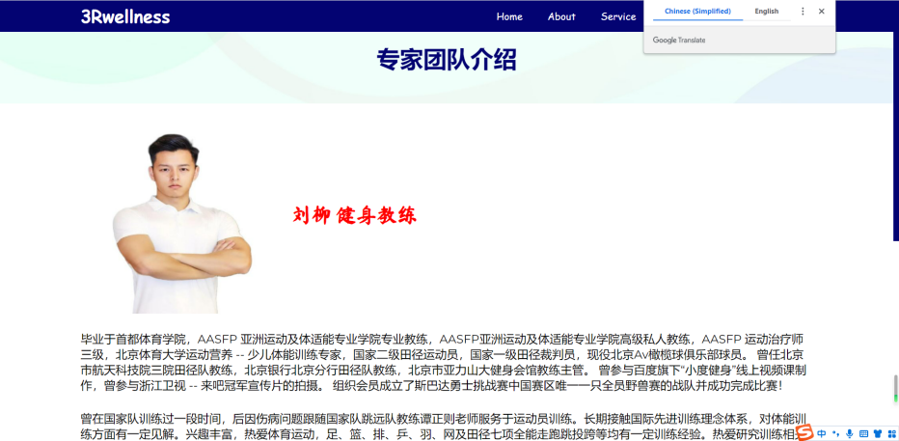

1. 用户预约页面 - Book Appointment Page

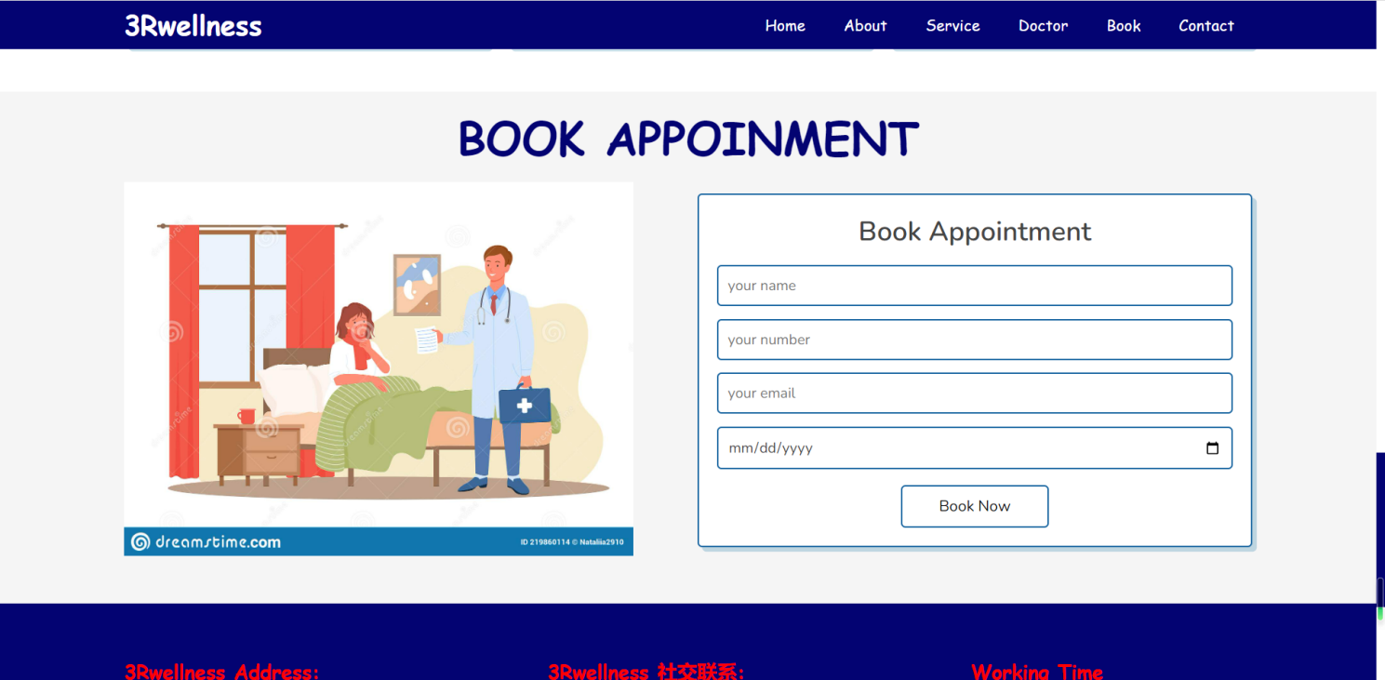

1. Contact Part

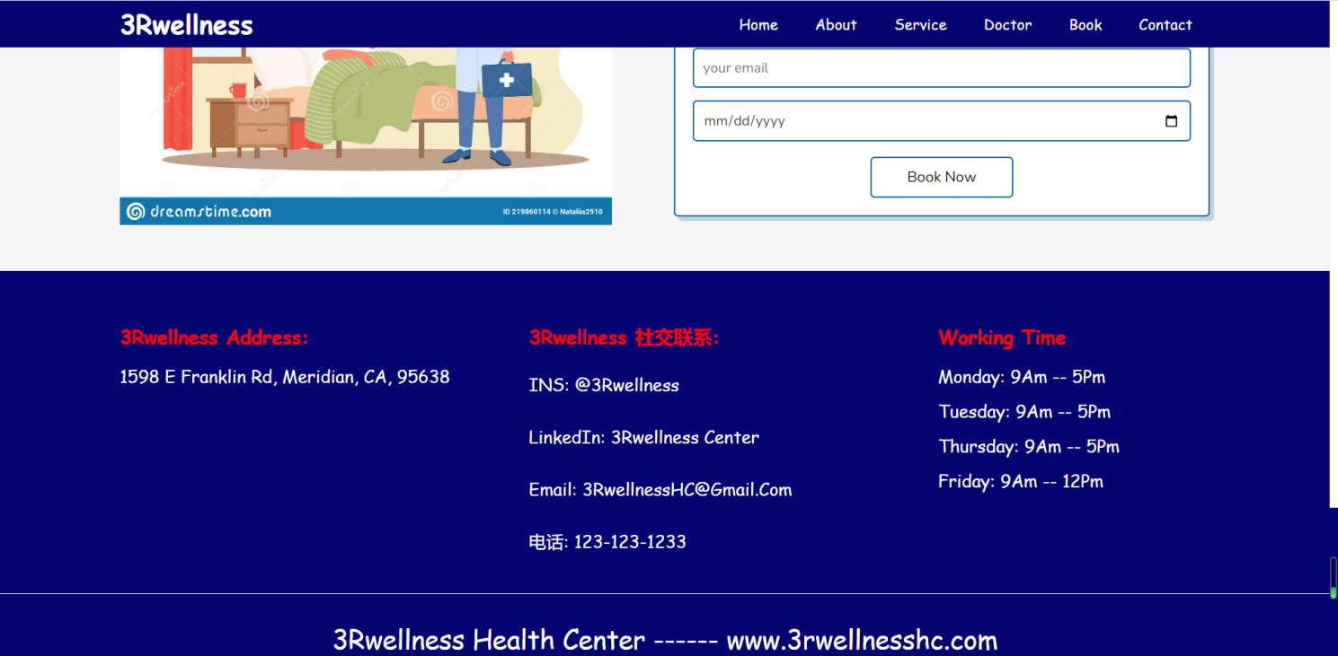

Chenyu Yang

02/23/2023